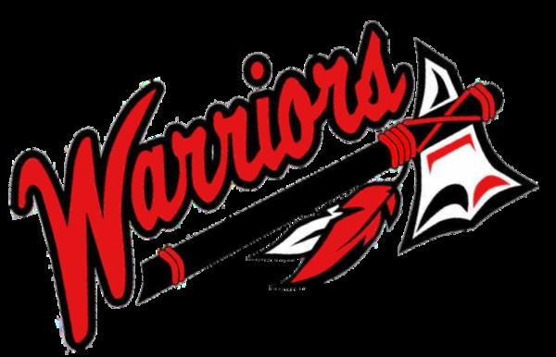
ROBIN HILL PUBLIC SCHOOL
4801 EAST FRANKLIN ROAD
NORMAN, OK 73026
405-321-4186 PHONE
405-321-5179 FAX
BRANDON VOSS, SUPERINTENDENT
bvoss@robinhill.k12.ok.us

Dear Parents,
The Robin Hill Teachers have voted to extend the walkout into this week. The length of this walkout is still unknown. We will continue to keep you updated, as information is available to us. I know that many of you are concerned about your students state testing. We are also very concerned. This morning the State Superintendent moved the testing window back one week. The 6th, 7th and 8th grade online testing deadline is now May 4th. The 3rd, 4th, and 5th grade paper and pencil-testing deadline is April 27th. As of right now we have begun constructing a modified testing schedule that will move testing back as far as we possibly can. We plan to begin testing April 16. Our goal is to complete the paper and pencil testing by April 20^{th,} so that we can receive the preliminary results this summer. I appreciate all of you who have volunteered to help with students and testing.
Concerning the calendar, we will have school on May 4th, 11th, and the 18th. These are Fridays that were scheduled as snow days. Any further calendar decisions have not yet been made.
I appreciate the feedback that each of you has voiced. No matter where you stand on the subject of the walkout, I hope that once classes resume, we can get back to making sure that Robin Hill is the extra-special place it has been for countless students and parents. The sense of family and love are what has set us apart from other districts. While storms and difficult situations have confronted us in the past, we have always persevered and continued to excel. This will not change. Thank you for continuing to support Robin Hill.

Sincerely,

Brandon Voss
Superintendent

